Architecture Backend Documentation

PSIsafe Primary Structures:

- PSIsafe Client and Server Install
- Backend SQL(Ensure SSMS is installed for easy GUI managment of Databases)
- Hard Drive
On-Premise and Cloud is on site and Cloud is running on our servers.
Sometimes On-Premise is installed on Azure and AWS. While on a cloud server it is still defined as On-Premise as we do not host the instance.
Typically, on an On-Premise environment you install SQL Server 2008 R2 SQL Express, Standard, Enterprise, and Web. All SQL Server 2008 R2 and up are compatible with PSIsafe. Those SQL Server versions Express is limited to the amount of RAM to 1.4 GB and 10 GB of hard drive space. Limits the number of users that can be added.
SQL Express Limitations: 1.4 GB/ 10GB database size. 10-15 PSIsafe users. (Technical Support should be handled for SQL Databases by the end users IT department). Kind of a toss-up on how we handle SQL Database issues. Defer to IT support and provide the script and shrinking script. We should also do billable hours if we are going to be doing any maintenance on SQL backend for clients.

At Login and Database Backend:

- If the Login is greyed out the server is not responding or pointing to the correct database location.
- There are two difference of installed for PSIsafe so it could be either On-Premise or CLOUD.
- You can have a PSIsafe Server, File Repositories, and the SQL Server can be located on another environment.
- Customer Code is only used for Cloud and by default customer code for On-Premise is usually set to Default.Typically On-Premise is 1 database per customer.
- When you install PSIsafe Server you get three services. CNG-FullTextSearch, CNG-WorkflowService, CNG-Server. Great indicator of where the Server is installed.
- New Customer will need to have Server Installation Package and the Client Installation Package. Server Installation is going to install the three services and the Client installation is the physical GUI for PSIsafe. When installing the Server and Client it is 32-bit client installed under Program Files (x86).
- You can see if server is installed by also looking at the Program Files(x86) CNG > CNGServer installed. Need to know where the Server is installed go to the CNG-Server > Right Click > Properties > General > Path to Executable.
- If the client has 64 - bit server the Cabinet Server. 64 - bit server is used for built for the API. Hosting their own Redtail, Mobile, and Share.
- CNG will automatically create a repository with the structure.
  - It will create CNG>[Cabinet ID found in dbo.Cabinets]>Folder will be named [F1]>Documents will be named [D1.eot]
    - .eot extension is a mask so that the users do not know what file type it is.
  - It will also create dbo.Cabinets in the Database.
  - Folders and Documents will be called dbo.F[Cabinet ID] and the dbo.D[CabinetID]
  - You can right click on a document and right click and look at Document Information.
    - Click on Ctrl-Close you will get additional information on the backend location within the SQL Database.
    - Sometimes a client will not be able to access because the associated image does not exist in D.eot form or permissions for the CNG-ServerService does not have access to the end point repository.
- The backend Database can be called CNG_Main, but the Database can be named whatever you like.
- Cloud client’s backend Database will be named CNG_[Customer Code] in the production environment.
- CNGForms is legacy with OMNIform this is not used any longer in the database. This will eventually be completed retired the CNG_Main is the major Database locations. Only if customers are using CNG Forms or XFM Forms will that database CNGForms be needed. Forms Signatures goes with the CNGForms for legacy clients. In Management Forms>Signatures will be retired or hidden at some point.
  - House the XML based forms that were previously used.
- The CNG-Safe folder under the install directory is where the client resides with Management.
- If you cannot find data in Salesforce go to Main > Cabinet Clients> Look at Notes.
- Look under PSIGEN > SF Accounts
- Look in Cabinet Inactive Clients under the Repository > Main

Service Definitions:

- CNG-Server is the main communication service. This is the main service that the client communicates with. If you cannot communicate with the service the connect to Login button is greyed out check connection settings or check the CNG-ServerService. Web and Mobile and if you want to keep users out of the system stop the CNG-Server if you are doing backend data storage. If there are access issues to the repositories you need to set CNG-ServerService to an account that can access the Repositories.

- CNG-FullTextSearch the ability to search document content. Document has to be a text-based document or searchable PDF that can be searched within PSIsafe. It does not full text create documents it just indexes already text-based documents. Troubleshooting tip if they cannot search documents contents ensure the service is started on the CNG Server and also that Enable Indexing is turned on under Cabinets. Repositories need to be set to UNC paths for access to the repositories. If Full Text is enabled and running you will see a FullTextSearch available in the repository that fully indexes all the documents in the Repository. You will see .ix files that are created.

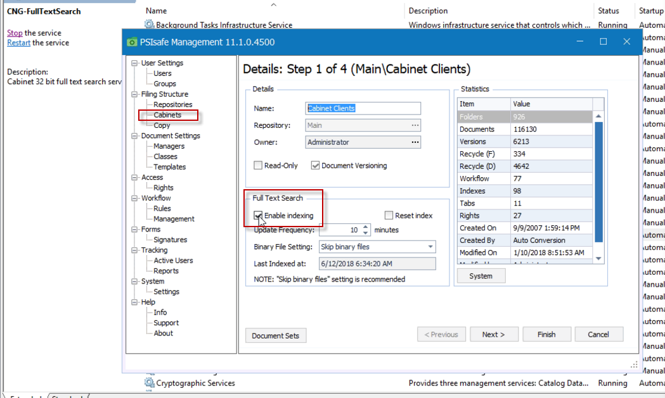

- CNG-WorkflowService is a notification service for emails. This is the service that sends out the email notifications. If clients are not getting emails ensure the service is running. Also ensure that the System >Settings>Notifications and Alerts and ensure the right SMTP are set properly. User Profile email address.
  - Typically, the users IT will look at this and ensure the SMTP settings are enabled.

Learning Resources:

CabinetHQ > Knowledge Base> Did you Know...

