## Overview

Workflow Auto Processing is a separately licensed module that enhances the functionality of Auto Import. When enabled, the workstation can be tailored to automatically process workflow steps for existing, checked-in batches in the Batch Manager.

## Configuration

Configure Workflow Auto Processing on the Auto Import configuration screen. Enable auto import on the *Auto Import* tab, select the *Workflow Auto Processing* tab, and check the box labeled *Enable Workflow Auto Processing on the local machine*.

By default, normal auto import processing will still take place on the workstation when it is not busy processing workflows. To prevent normal auto import processing, check the box labeled *Disable normal Auto Import processing*.

Use the *Processing Mode* combo box to select one of the two operating modes for Workflow Auto Processing:

* *Auto process individual workflow steps* – This mode searches for closed but incomplete batches that are waiting to perform one of the workflow steps you specify. The search ignores exception batches, suspended batches, and batches configured to attempt auto processing of the batch through its workflow. The processor will check out the batch, perform the step, and then check in the batch. Choose the steps from the *Available* list and add them to the *Selected* List. The order of the steps determines precedence.

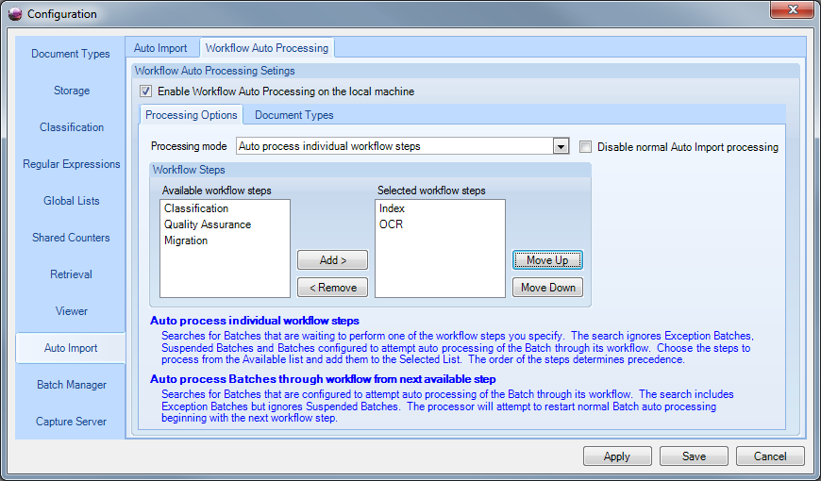

*Figure 1: Sample configuration for auto processing individual workflow steps*

* *Auto process full batch from next available step* – This mode searches for closed but incomplete batches that are configured to attempt auto processing of the batch through its workflow. The search includes exception batches but ignores suspended batches. The processor will attempt to restart normal batch auto-processing beginning with the next workflow step.

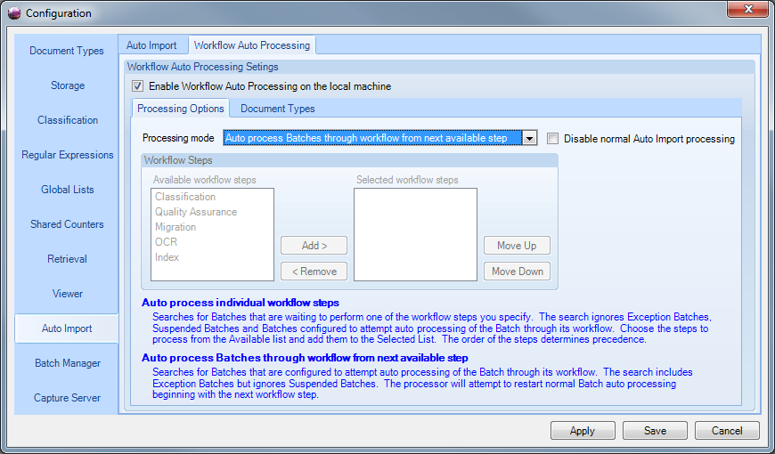

*Figure 2: Sample configuration for auto processing full batches*

Use the *Document Types* tab to determine which document types will participate in workflow auto processing. To process all document types, select the *Process all document types* setting in the *Mode* combo box. To select specific document types, choose the *Process selected document types* mode and select the desired document types in the list.

Normal auto import operations are not affected by these settings.

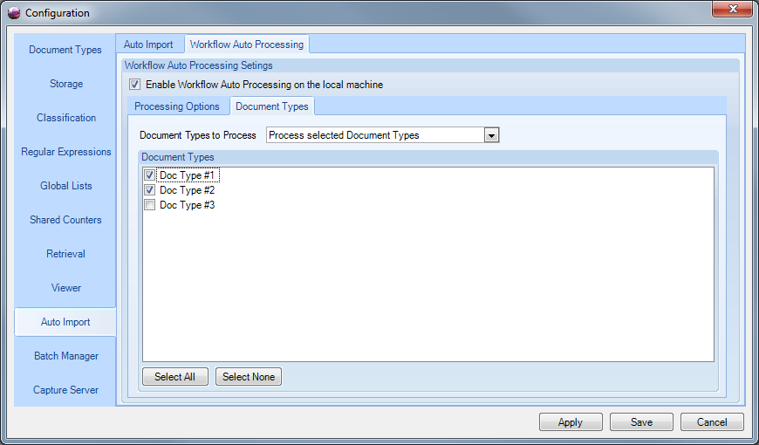

*Figure 3: Document type filtering*

The status screen on the Auto Import tab now reflects how workflow auto processing is configured for each workstation:

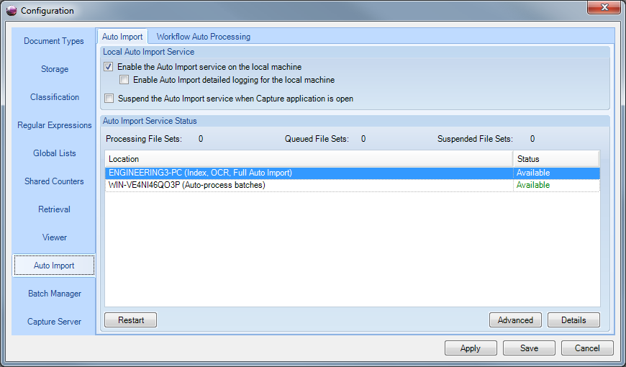

*Figure 4: Updated status screen*

## Considerations

* Batches are selected for processing in ascending order by batch ID. Batches marked as high priority are processed first.
* While a workstation can be configured to perform both normal auto import and workflow auto processing, the workstation can only perform one of these operations at a time. Workflow auto processing has priority over auto import, so configure enough normal auto import stations to prevent bottlenecks with queue processing.
* The check box *Attempt to Auto Process Batch through Workflow* in document type configuration step 9 of 10 has direct bearing on whether or not a batch is processed by a workflow auto processing workstation.

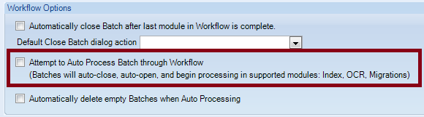

If checked, batches derived from the document type will only be processed by workstations with mode “*Auto process full batch from next available step*“ assigned. If not checked, their batches will be processed only by workstations with mode “*Auto process individual workflow steps* “ assigned.